ST0249   
AI & Machine Learning

Practical 10  
Cognitive Services



What you will learn / do in this lab

1. Explore cognitive services and applications
2. Conduct experiment using visual cognitive service

TAble of  
Contents

1. Overview 1

Introduction to Cognitive Services 1

2. Visual Recognition 2

# 1. Overview

In this practical we will be exploring what are cognitive services. We will also be setting up a simple web application that using a visual recognition service to recognize images and classify objects correctly.

## Introduction to Cognitive Services

Microsoft Cognitive Services (formerly Project Oxford) are a set of APIs, SDKs and services available to developers to make their applications more intelligent, engaging and discoverable. Microsoft Cognitive Services expands on Microsoft’s evolving portfolio of machine learning APIs and enables developers to easily add intelligent features – such as emotion and video detection; facial, speech and vision recognition; and speech and language understanding – into their applications.

<https://azure.microsoft.com/en-us/services/cognitive-services/>

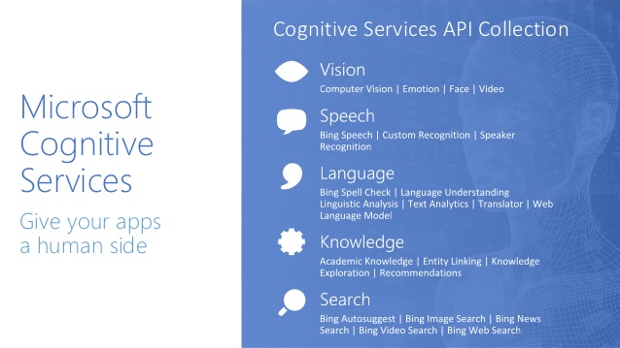

# 2. Visual Recognition

|  |
| --- |
| Objectives:  After completing this lab, you should be able to:   * Describe the Microsoft Custom Vision Service * Describe how to train a classifier * Learn how to use the prediction api |

**Exercise 1. Sign up with the Custom Vision Service**

Visit the following URL

<https://azure.microsoft.com/en-us/services/cognitive-services/custom-vision-service/>

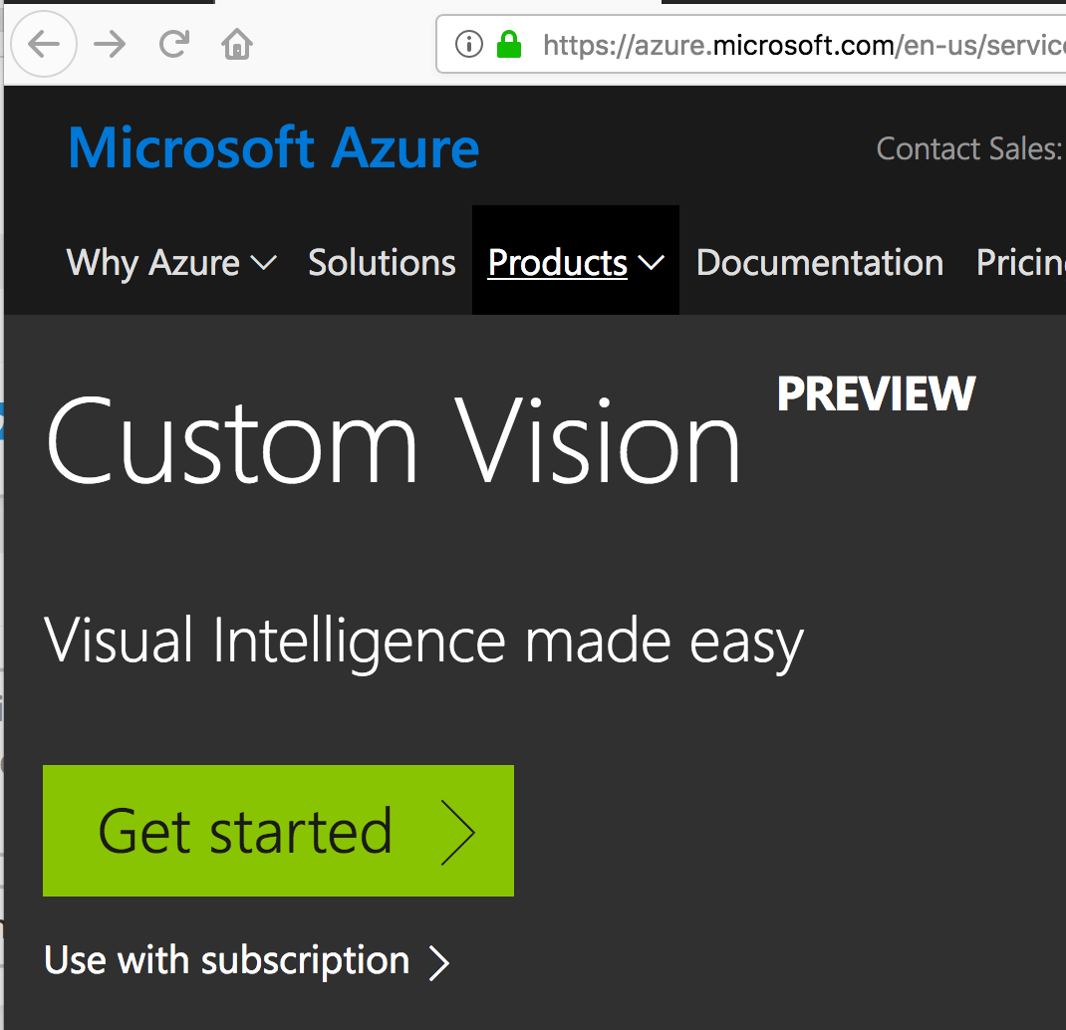

Tap **Get Started -> Sign In**

Create a new account if you don’t have a Microsoft account

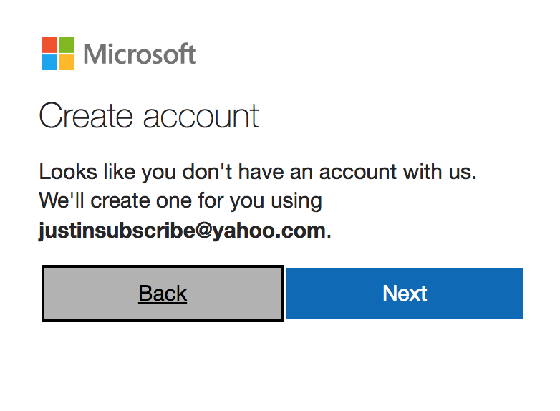

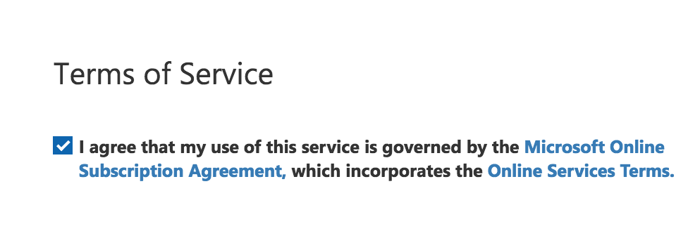

Accept the Terms of Service

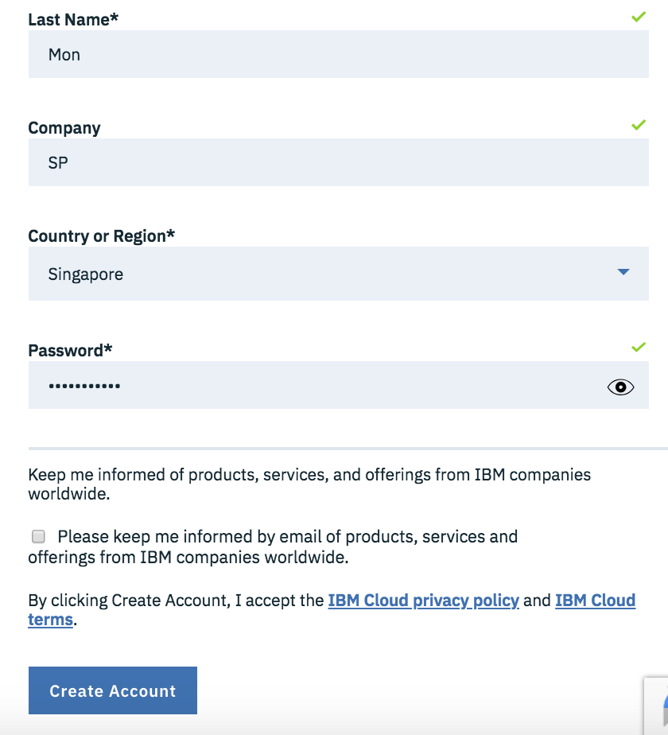

**Exercise 2. Create a New Project**

Type the project name

Click **Create Project**

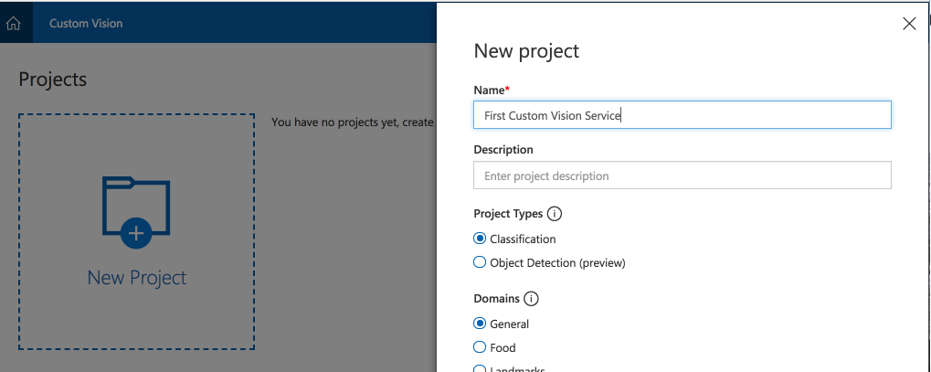

Click **Add Images->Browser Local Files**

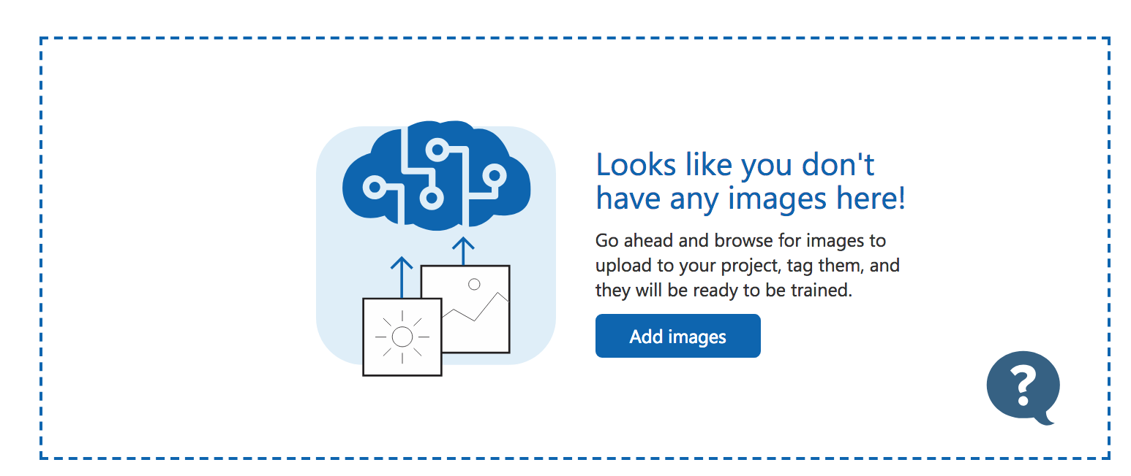

Add the images (Images will be provided). In the **My Tags** textbox type **dogs**

Upload the images by clicking **Upload**

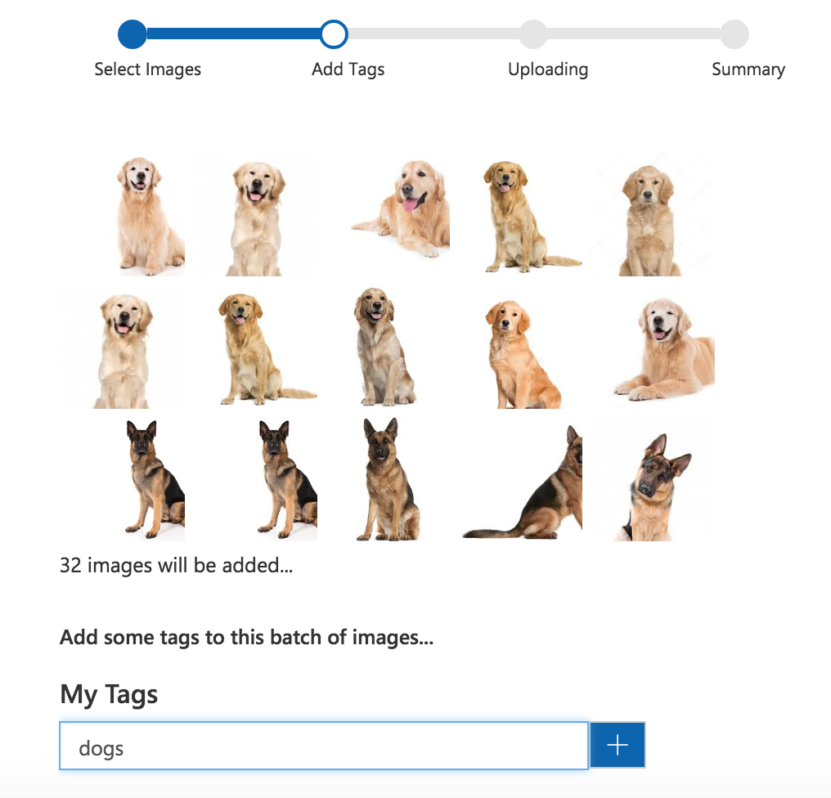

Click on Training Images tab. For each image manually tag as **Bulldog**, **German Shepard**, and **Golden Retriever**

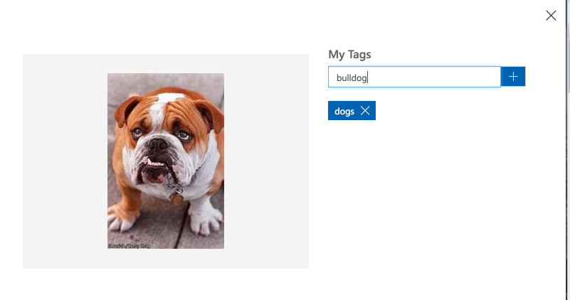

Train the model by clicking the button



**Exercise 2. Use The Prediction API**

Click the Predictions tab -> View Endpoint

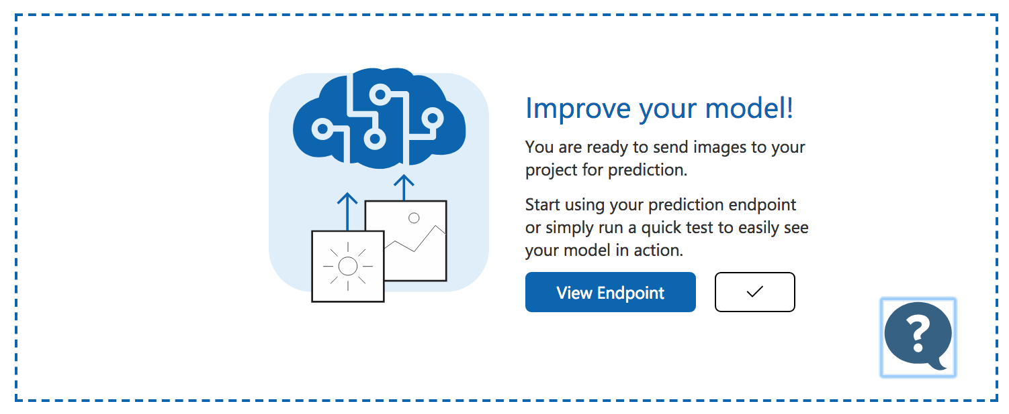

Note that you are provided the following input information:

Request url

Prediction-Key header,

Content-Type header

Body to place the image url

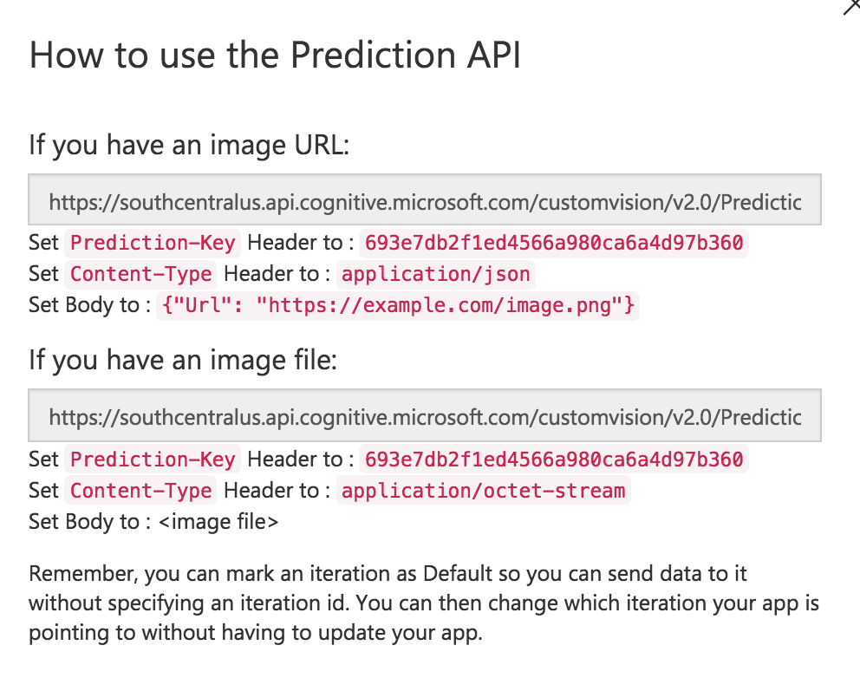

Tap  to test an image with the classifier

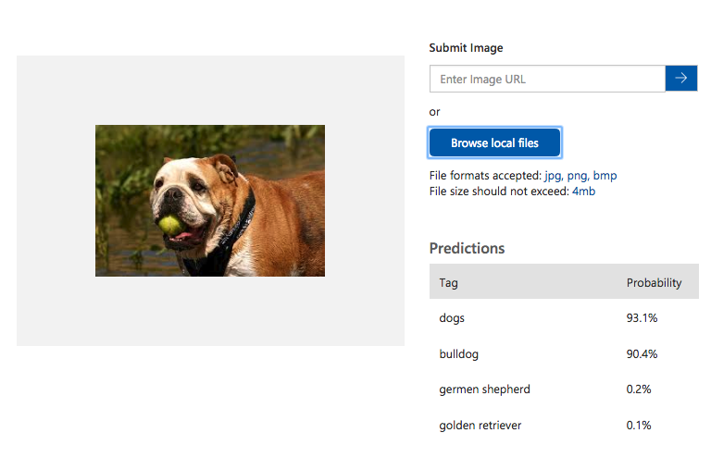

**Exercise 3. Write a program to use the prediction api**

The following code will send a post request to the prediction api with an image url

You can access the full program at:

<https://drive.google.com/open?id=1iyeSQAoJ2_7tSDBwJgZ-h9EmMmLQcQHD>